COURSE: AI Assisted Coding NAME: R.Karthik
BATCH-35
HALLTICKET.NO:2303A52202

Lab4:AdvancedPromptEngineering:Zero-shot,one-shot,and few shot techniques

Objective:ToexploreandcompareZero-shot,One-shot,andFew-shot promptingtechniquesforclassifyingemailsintopredefinedcategories using a large language model (LLM).
- Suppose that you work for a company that receives hundreds of customer emails daily. Management wants to automatically classify emailsintocategorieslike"Billing","TechnicalSupport","Feedback", and "Others" before assigning them to appropriate departments. Instead of training a new model, your task is to use prompt engineering techniques with an existing LLM to handle the classification.

Taskstobecompletedareas below
  - PrepareSampleData:
- Createorcollect10shortemailsamples,eachbelongingtooneof the 4 categories.
  - Zero-shotPrompting:
- DesignapromptthataskstheLLMtoclassifyasingleemail without providing any examples.
- Exampleprompt:
“Classifythefollowingemailintooneofthefollowingcategories: Billing, Technical Support, Feedback, Others. Email: ‘I have not received my invoice for last month.’”

  - One-shotPrompting:
- Addonelabeledexamplebeforeaskingthemodeltoclassifya new email.
  - Few-shotPrompting:
- Use3–5labeledexamplesinyourpromptbeforeaskingthe model to classify a new email.
  - Evaluation:
- Runallthreetechniquesonthesame setof5test emails.
- Compareanddocumenttheaccuracyandclarityofresponses.

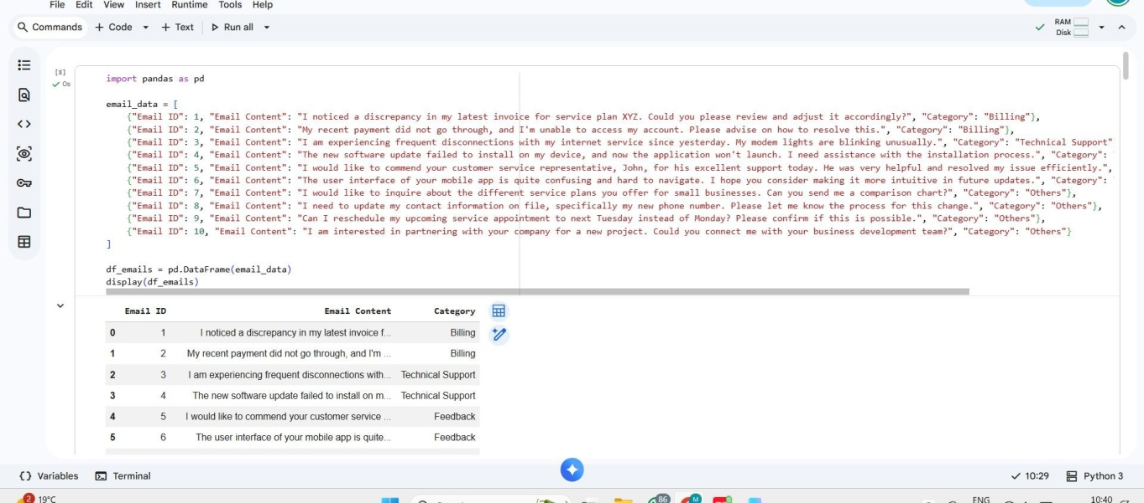

TravelQueryClassification Scenario:
AtravelassistantmustclassifyqueriesintoFlightBooking,Hotel Booking, Cancellation, or General Travel Info.

Tasks:
  - Preparelabeledtravelqueries.
  - ApplyZero-shotprompting.
  - ApplyOne-shotprompting.
  - ApplyFew-shotprompting.

  - Compareresponseconsistency.
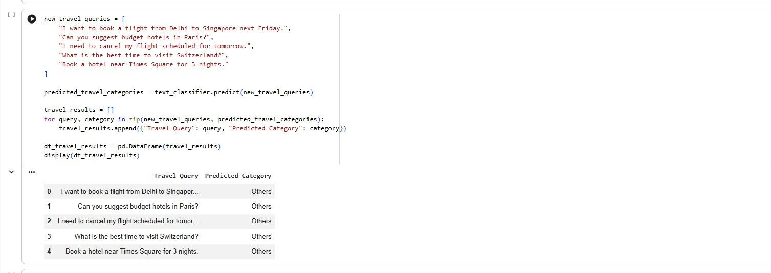
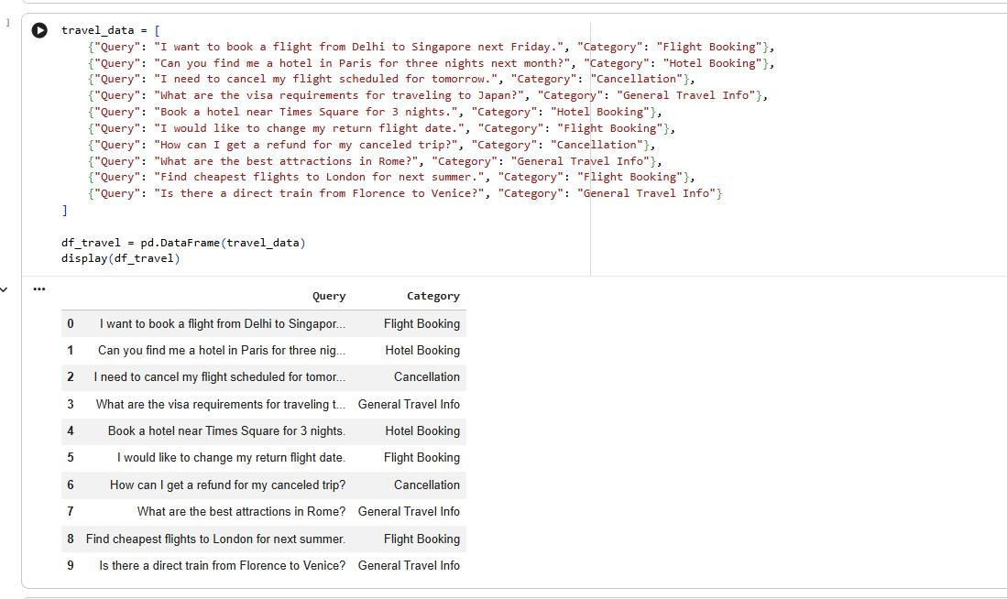

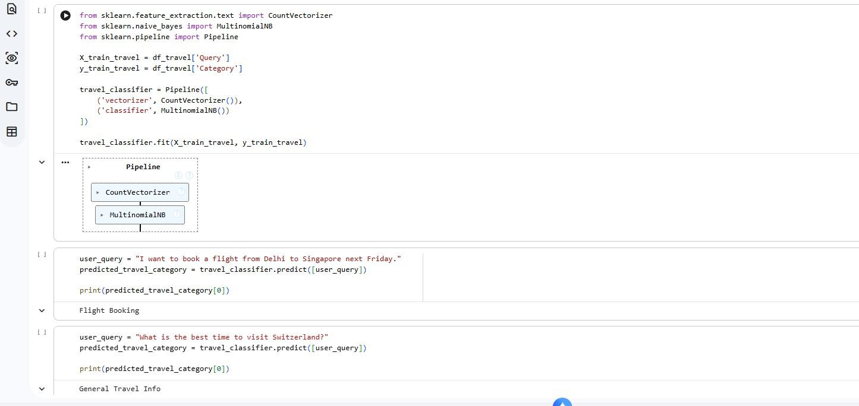

ProgrammingQuestionTypeIdentification

Scenario:
AcodinghelpchatbotmustclassifyqueriesintoSyntaxError,Logic Error, Optimization, or Conceptual Question.
Tasks:
  - Preparecoding-relateduserqueries.
  - PerformZero-shotclassification.
  - PerformOne-shotclassification.
  - PerformFew-shotclassification.
  - Analyzeimprovementsintechnicalaccuracy.

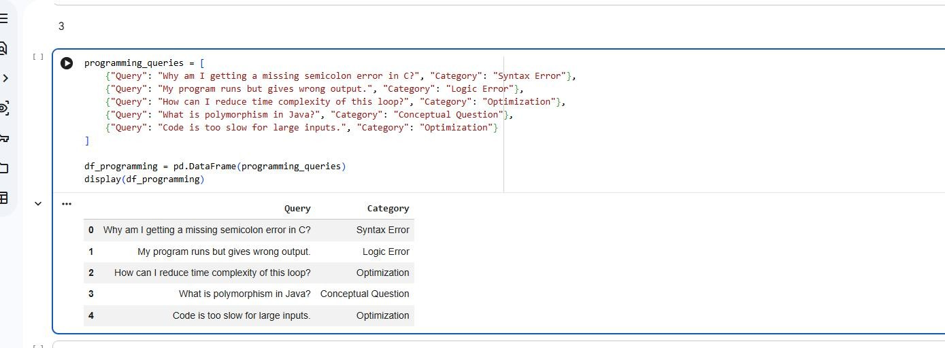

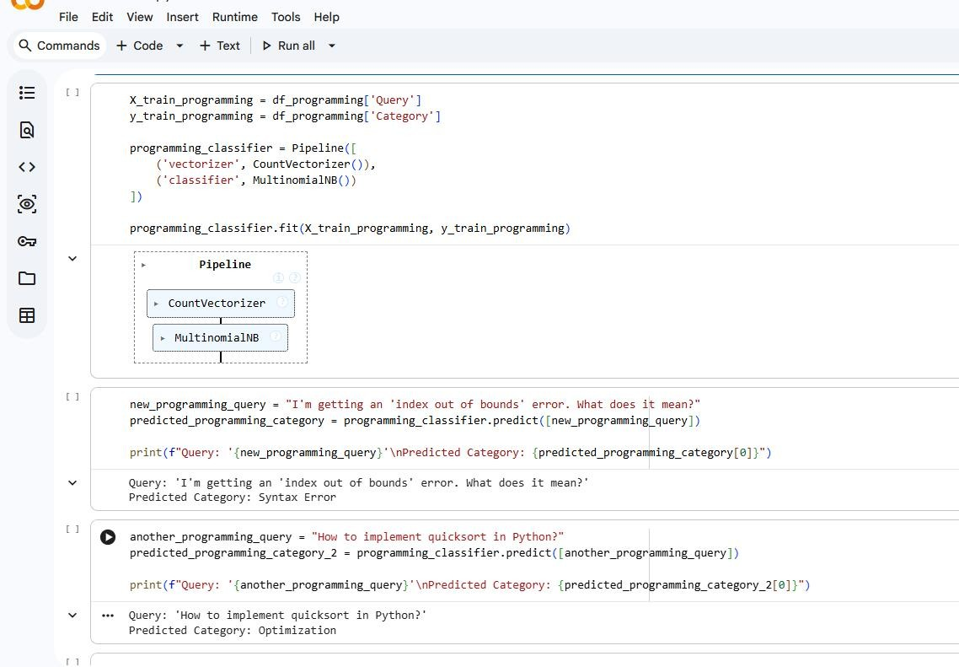

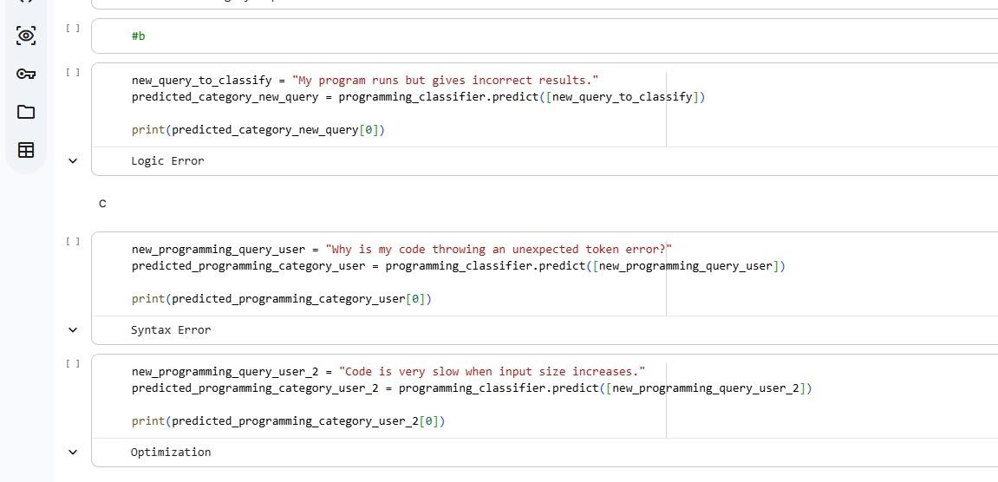

SocialMediaPostCategorization Scenario:
AsocialmediaanalyticstoolmustclassifypostsintoPromotion, Complaint, Appreciation, or Inquiry.
Tasks:
- Preparesamplesocialmediaposts.
- UseZero-shotprompting.
- UseOne-shotprompting.
- UseFew-shotprompting.
- Analyzeinformallanguagehandling
